Disturbance Response Monitoring 2024 In-Water Protocol

Site Selection
All sites will be predetermined, and GPS coordinates will be assigned to each dive team in advance of the survey start date. The FRRP DRM sampling approach is a probabilistic survey design using a randomized stratification appropriate for population census and prevalence. The primary sampling unit is a ‘site’ defined as a 50m x 50m cell where four transects will be surveyed. A ‘transect’ is defined as a 10m x 1m belt survey area on the reef. At a minimum, the survey design calls for two sites per reef ‘stratum’. The strata have been refined in recent years and is based on sub-regional divisions, cross shelf divisions, habitat type, and bathymetry. This stratification framework continues to be revisited each year and is being iteratively improved to more accurately describe how reef community types are organized. More sites are allocated to strata with higher variability such as patch reefs.
The sites assigned to each stratum will have a primary and secondary set of GPS coordinates. Surveyors should first attempt to locate coral habitat at the primary coordinates by searching within a 25m radius around the GPS point. If suitable (hardbottom) coral habitat is found, proceed to survey the site. If suitable habitat is not found within the 25m radius surrounding the GPS point, you may proceed to another primary coordinate, within the same stratum, or, if this is not possible, to a secondary coordinate within the same stratum and repeat the procedure. If suitable survey habitat is not found at either the primary or the secondary site, you may choose an area known to have hardbottom/reef within the same FRRP stratum and survey it as a “strategic site”. Strategic sites (sites not within 25m of a primary or secondary coordinate within a stratum) will be assigned a site number when data is recorded in the online data entry system at (http://ocean.floridamarine.org/FRRP/). Once suitable survey habitat is identified at a site, record the GPS coordinates of the buoy used to mark the location.

Benthic Survey
Equipment Needed: DRM transect datasheets, dive slate with pencil, coral measuring stick, metered line to mark the extent of the transect, and underwater camera (optional). When choosing a measuring device, a rigid measuring stick must be used to collect the straight diameter of the coral and not the curved length of the coral. We recommend a half meter or meter-long 1” PVC pipe with markings.
Belt Transect Setup: Navigate to your site and assess the benthos to be sure it has appropriate coral habitat. Once suitable habitat is identified, survey the site. If the coordinates of the surveyed area differ from the original site coordinates, be sure to transcribe the new coordinates at the top of the datasheet.
To survey a site, divers will haphazardly lay four 10m x 1m belt transects along the reef. Transects will be identified as T1, T2, T3, and T4. Transects T1 and T2 will be surveyed first followed by T3 and T4. Transects should not overlap each other or overlap the same coral at a site. Transect lines should be secured using a weight or by tying it off to a non-living feature on the substrate. The transect line should be stretched taut to ensure that 10m of reef is covered with each survey. Large patches of sand or unconsolidated coral rubble should be avoided.

At each site, record the following information on your UW datasheet before each dive.
- Pre-assigned DRM Site Code
- Latitude in decimal degrees (As determined by dGPS)
- Longitude in decimal degrees (As determined by dGPS)
- Date
- Surveyor
- Transect 1, 2, 3, or 4 – This helps differentiate between transects during data entry.
- Buddy – Your dive buddy
It is strongly recommended that each team member fills in every category. If possible, only record one survey or site per datasheet to avoid confusion between site data.

If a transect is split between two surveyors, surveyors should work towards each other from opposite ends of the line (i.e. starting at 0m or starting at 10m) and care should be taken to not count a coral twice. Do not split a transect longitudinally (i.e. left and right sides of transect tape) as this can result in corals being measured twice. Be sure to record the name of the person who split the transect with you within your metadata on the datasheet (and within the online data entry).
The measuring tape will delineate the middle line of the survey – survey 50cm off either side of the transect tape; do not survey 1m off one side of the tape.
Belt Transect Survey - Transects 1 and 2 (T1 and T2): Haphazardly lay out two 10m transects on the reef. Record the depth at the start of the transect (at 0m end of tape) and circle the appropriate habitat at the top of your datasheet. Swim the length of the transect and record all LIVE adult stony coral colonies > 4cm that have any portion of the colony (live or dead) within the boundaries of the 10m x 1m transect using the four-letter species code. A live coral is defined as any coral with any amount of living tissue or recent mortality on any portion of the colony.
In addition to the adult coral assessment, tally all juvenile corals (≤4cm and >1cm) of Montastraea cavernosa and the target coral families (Mussinae, Faviinae, and Meandrinidae) that lie within the boundaries of the transect. Tallies are recorded at the bottom of the underwater datasheet.
Use a measuring tool to ensure that 50cm of reef is being surveyed on each side of the transect tape. *Note: Millepora spp. are no longer recorded in the surveys.
Belt Transect Survey - Transects 3 and 4 (T3 and T4): T3 and T4 can be done after T1 and T2 are complete or at the same time if more than two divers are present at a site. Typical DRM surveys are done with two divers where each diver completes a transect. Divers can follow this same method and then move on to each survey either T3 or T4. T3 and T4 should also be haphazardly laid out on the reef making sure to not overlap any area that was surveyed on T1 and T2. The only information that needs to be filled in at the top of your datasheet for T3 and T4 should be the Site, Surveyor, and Transect Number. No other site information is needed since it was already captured at T1 and T2.

Once the transects are laid out, swim the length of the transect and record only the LIVE adult stony coral colonies > 4cm of the 10 target species that have any portion of the colony (live or dead) within the boundaries of the 10m x 1m transect using the four-letter species code. The 10 target species are as follows: Colpophyllia natans, Dichocoenia stokesii, Diploria labyrinthiformis, Meandrina meandrites, Mussa angulosa, Mycetophyllia aliciae, Mycetophyllia ferox, Mycetophyllia lamarckiana, Pseudodiploria clivosa, and Pseudodiploria strigosa. These species and their species codes are greyed out and listed on the right side of the datasheet for reference (Figure 1).

Juvenile coral tallies (≤4cm and >1cm) of Montastraea cavernosa and the target coral families that lie within the boundaries of the transect will also be tallied along T3 and T4.

Use a measuring tool to ensure that 50cm of reef is being surveyed on each side of the transect tape.
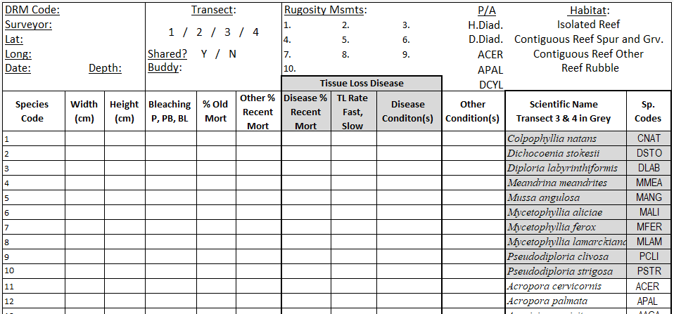
Figure 1. View of the top of the DRM datasheet for the 2024 season. Target adult coral species for Transects T3 and T4 are greyed out and listed on the right side of the datasheet outlined above in the red box.

Benthic Transect Surveys – How to Measure and Record Corals:
- Measuring Adult Colony Dimensions: For stony corals >4cm, measure the maximum diameter of the outward-facing colony surface, perpendicular to the axis of growth, and the maximum height, parallel to the axis of growth. Record these measurements to the nearest centimeter.

Colony boundaries can be difficult to recognize when parts of the coral have died and are overgrown by other organisms. Look for connected live tissue, connected skeletal deposits above a common base, and at the size and color of separated polyps. Colony margins with old mortality may be overgrown with macroalgae, turf algae, sponges, other coral species, etc. Example images are provided in Figures 2, 3 and 4.

- Measuring Adult Coral Colonies Not Attached to the Substratum: All colonies >4cm with live tissue or recent mortality that are attached or unattached to the substratum that lie within the boundaries of the 1m x 10m transect should be recorded on your datasheet.

If the colony has recently detached or fallen, record the length, height and % mortality as if it were still upright.

If the colony has reoriented to grow upward in its new position (i.e., has been detached from the substratum for some time), the “new” maximum length and maximum width should be measured, and the new outward-facing surface used for calculating % mortality.

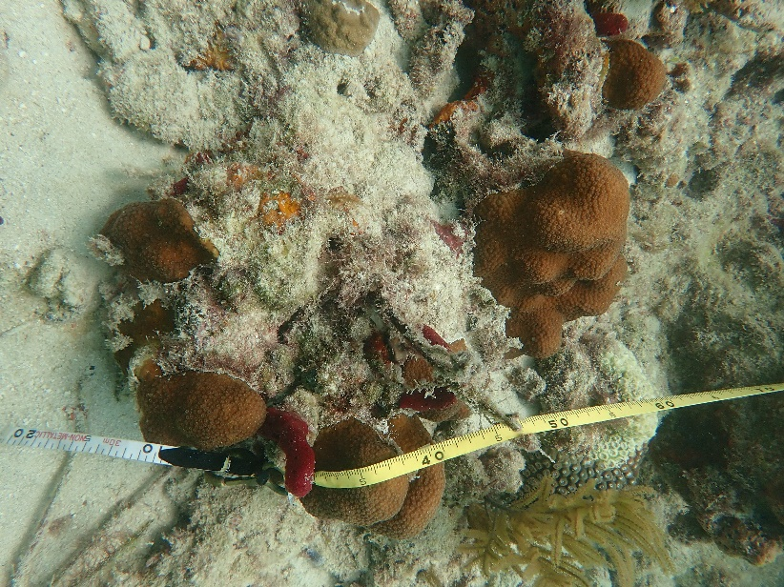
Figure 2. Orbicella annularis colony tissue isolates separated by dead coral skeleton.

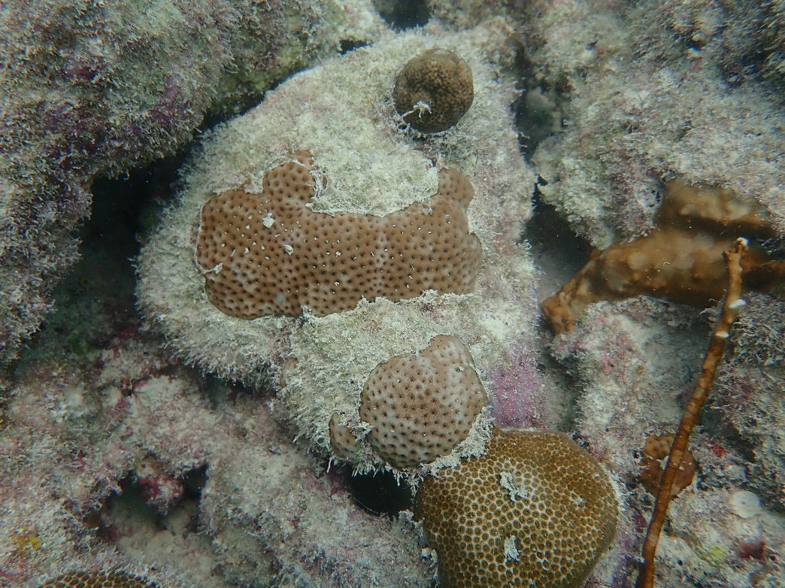
Figure 3. Siderastrea siderea colony tissue isolates separated by dead coral skeleton (red circle) with Porites astreoides (blue circle) growing on top of the dead substrate.
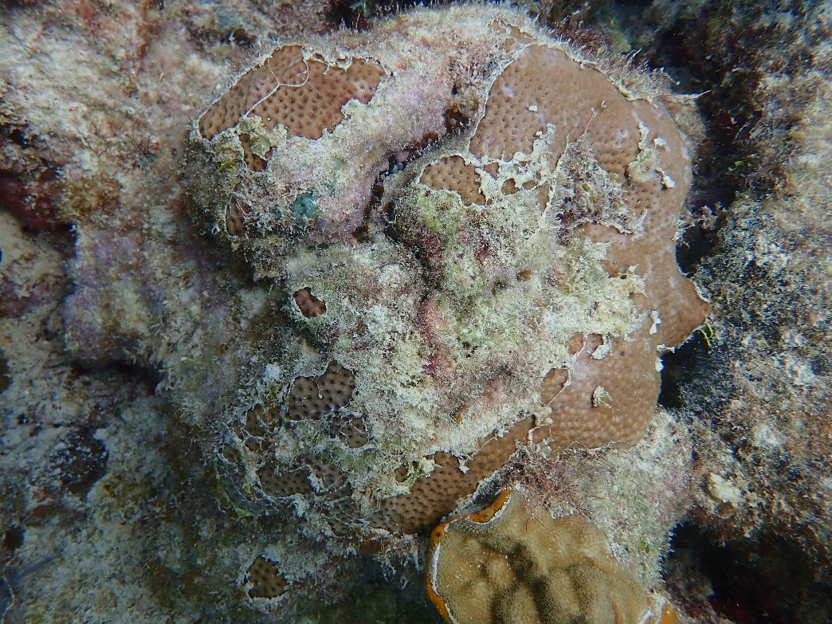
Figure 4. Siderastrea siderea colony tissue isolates separated by dead coral skeleton (red circle).

- Recording Bleaching Conditions for Adult Coral Colonies: Visually scan live portions of each adult coral colony for loss of tissue color caused by bleaching. Characterize any bleached tissues as approximate severity of color loss using the following codes:

  - Blank = No bleaching
  - P = Pale (fading of color; lighter color)
  - PB = Partially Bleached (patches of fully bleached or white tissue)
  - BL = Bleached (tissue is totally white, no zooxanthellae visible)

Note: It is important to be able to differentiate between bleached or translucent tissues and recently dead skeletons. Many severely bleached corals are translucent, but you can still see the polyp tissues above the skeleton. Bleached tissues should not be included with the “% Recent Mortality” estimates.

- Estimating Mortality on Adult Colonies: Estimate the partial mortality (old and recent) of the whole colony surface. Round partial mortality to the nearest 5% unless mortality is very small or very large, in which case round to the nearest whole number (e.g., 1%, 97%).

Characterizing Mortality on Adult Colonies:

  - "Old Mortality" is defined as any non-living parts of the coral in which the corallite structures are either not distinguishable or covered over by organisms that are not easily removed (macroalgae, thick turf algae, and invertebrates).

  - "Other Recent Mortality" is defined as any non-living parts of the coral in which the corallite structures are either white and still intact or slightly eroded but identifiable to species. Recently dead skeletons may be covered by sediment or a thin layer of turf algae. ‘Other’ refers to any non-disease related lesions such as predation, abrasion, overgrowth of other organisms, interaction with other organisms or sediment cover. The cause of the lesion will be identified in the last column of the datasheet under “Other Conditions” using the pre-defined letter codes outlined below.

If recent mortality from non-disease related conditions is identified, the “Other Condition” column MUST be completed. Characterize any “other condition” using the following terms.
      - PRD = Predation
      - OGI = Overgrowth and Interaction
      - ABR = Abrasion
      - SC = Sediment Cover
      - CLN = Clionid sp. – Can be recorded in the absence of tissue loss.
      - MUC = Mucus sheathing – Can be recorded in the absence of tissue loss.
      - OUK = Other Unknown Condition
      - TRS = Thermal Stress

  - “Disease Recent Mortality” is any disease related lesion(s). If recent mortality from disease is identified, the “Tissue Loss Rate” and “Disease Condition” columns MUST be completed. Disease data columns are to be completed even if a disease condition is well-defined and easily identifiable following the standard names given to known coral conditions (e.g., Black Band Disease). The cause of the lesion will be identified in the “Disease Condition” column of the datasheet using the pre-defined letter codes outlined below.

Characterize any disease(s) using the following terms.

TL Rate (Tissue Loss Rate):
      - FA = Fast – Recent mortality associated with a lesion which extends for approximately 1cm or more following the live/dead margin. Approximately is used because some observer discretion must be used depending on the colony size and nature of a lesion. 1cm is a guideline but is not meant to be hard rule.
      - SL = Slow – Recent mortality associated with a lesion which extends for approximately 1cm or less following the live/dead margin.

    - Diseases Condition(s): If more than one disease condition exists on a colony, multiple disease condition codes can be entered in the disease condition column.
      - Diseases Resulting in Tissue Loss
        - STL = Stony Coral Tissue Loss Disease or SCTLD – Focal or multifocal areas of acute (>5 cm) tissue loss often without a distinct margin (multi sp.).
        - WPL = White Plague Disease – Focal or multifocal areas of acute (>5 cm) tissue loss with distinct margin (multi sp.).
        - YB = Yellow Band Disease – Slow tissue loss following a narrow band of discolored yellow tissue.
        - BB/RB = Black Band or Red Band Disease – Slow tissue loss following a black or reddish filamentous band.
        - UNK = Unknown Disease – Any tissue loss disease that does not fit the descriptions of the ‘Known’ diseases below.
      - Acroporid Diseases Resulting in Tissue Loss: The below disease codes can only be entered into the ‘Disease Condition(s)’ column if an Acroporid coral species is selected in the species code column.
        - WBD = White Band Disease – Acropora spp. – 1cm to 5cm band of white coral skeleton.
        - WPX = White Pox Disease – Acropora palmata – Multifocal slow progressing tissue loss.
        - RTL = Rapid Tissue Loss – Acropora spp. – Fast tissue loss with irregular margins.
      - Diseases Not Resulting in Tissue Loss: The below conditions can be entered into the ‘Disease Condition(s)’ column but cannot be used to identify the cause of tissue loss if the % Disease Recent Mortality is greater than 0.
        - DSD = Dark Spot Disease – Focal or multifocal areas of dark discolored tissue.
        - DC = Discolored - Conditions that include any change in color (not loss of color/bleaching) compared to 1) the color of the tissue in healthy areas of the colony or 2) a color that would be considered normal for a given species if the whole colony appears affected.

- Photo Documentation of Coral Conditions: If the surveyor feels that the condition of the coral is not well defined by the data recorded on their datasheet or if there is an unknown disease condition that is inconsistent with other observations, they can choose to take a photo for better documentation. Photo documentation of corals along the transects or within the surrounding area are encouraged. This will allow for multiple sources of input from either your team or other DRM partners prior to entering your data online. However, ‘UNK’ or ‘OUNK’ are appropriate conditions when the cause of recent mortality cannot be determined. To identify which coral you are photographing, take a picture of your datasheet pointing to the appropriate coral first and then follow that image with a picture of the coral in question.

Photos can be uploaded to an FWC-hosted ‘DRM 2024 Images’ Google Drive folder. The Google Drive folder will act as the central repository for sharing images among the DRM partners. A link to the Google Drive folder will be available on the “Surveyor Trainings and Resources” page of the DRM website. Directions for labeling and uploading images are provided in the ‘DRM Data Entry Protocol’ that can be downloaded from the DRM website under the ‘Surveyor Trainings and Resources’ page (https://ocean.floridamarine.org/FRRP/Home/About).

- 100% Mortality with Recent Mortality: If a colony is 100% dead but contains any portion of recent mortality, it should be recorded on your datasheet. % Mortality totals (Old Mortality + Other Recent Mortality + Disease Recent Mortality) may equal up to 100% if the colony is entirely dead but may not be >100%.

- Tallying Juvenile Coral Colonies: Juvenile coral colonies (≤4cm) of Montastraea cavernosa and the target coral families (Mussinae, Faviinae, and Meandrinidae) should be tallied at the bottom of the datasheet. Species that fall within the target coral families are listed next to each family name on the datasheet as seen in Figure 5. No size measurements or condition data will be collected for juvenile coral colonies.
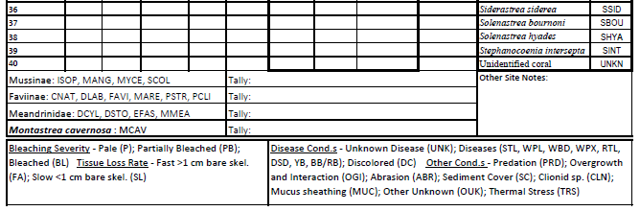
Figure 5. View of the bottom of the DRM datasheet for the 2024 season that includes boxes for juvenile coral tallies of Montastraea cavernosa and the target coral families. Next to each family is a list of species codes that fall within those families.
- Rugosity (Transects 1 and 2 ONLY): Measurements for rugosity will be taken while rolling up the transect line. To collect rugosity measurements, imagine that the 10m transect is subdivided into ten 1m x 1m subplots. Within each 1m x 1m subplot, measure the highest relief feature (not including “soft complexity” features such as branching gorgonians, sponges, and fire corals) from the seafloor to the “top” of the feature using your measuring device. Giant Barrel Sponges (Xestospongia muta) are considered a hardbottom feature. If surveying along a slope, height measurements are taken perpendicular to remain relative to the seafloor surface. The 10 rugosity measurements are recorded to the nearest cm at the top of your belt transect datasheet.

- Species Presence (Transects 1 and 2 ONLY): While laying out or taking in the transect line, assess the area within the transect and the area within visual range around the transect for the presence of diseased Diadema antillarum (D.Diad.) and/or healthy Diadema antillarum (H.Diad.). At the same time, assess the area within visual range around the transect for the presence of Acropora cervicornis (ACER), A. palmata (APAL) or Dendrogyra cylindrus (DCYL) that is not captured within the 1m x 10m belt transect. If encountered, circle their presence at the top of your datasheet. This data will be subject to underwater visibility and your view of the surrounding substrate.

Data Entry

After surveying, enter your data into the online data entry system (http://ocean.floridamarine.org/FRRP/) according to the prompts. Please check your data to verify its accuracy once it is entered. Instructions for entering data into the online data entry system are provided in the ‘DRM Data Entry Protocol’ document as well as the ‘Online Data Entry System Training’ training module that can both be downloaded from the ‘Surveyor Trainings and Resources’ page on the website (http://ocean.floridamarine.org/FRRP/).

Questions

Please contact the DRM Program Manager with DRM questions or problems.

Coral DRM Program Manager
Coral Program, Florida Fish and Wildlife Research Institute
CoralDRM@MyFWC.com

